How to organize EEM data in excel:

1. Open new Excel – name = [date] full data
2. Every sheet (גיליון) is a sample. Name it.
3. 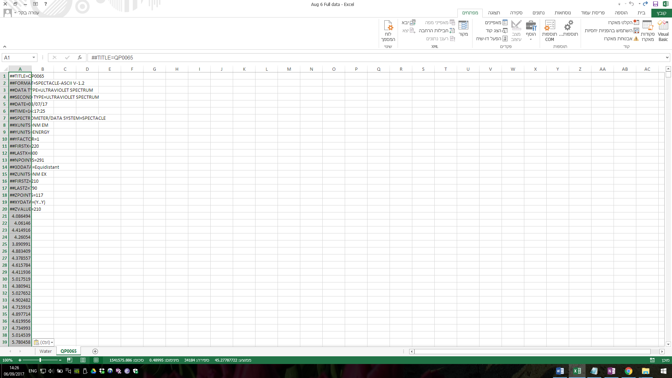Copy the .ASC to the file.
4. 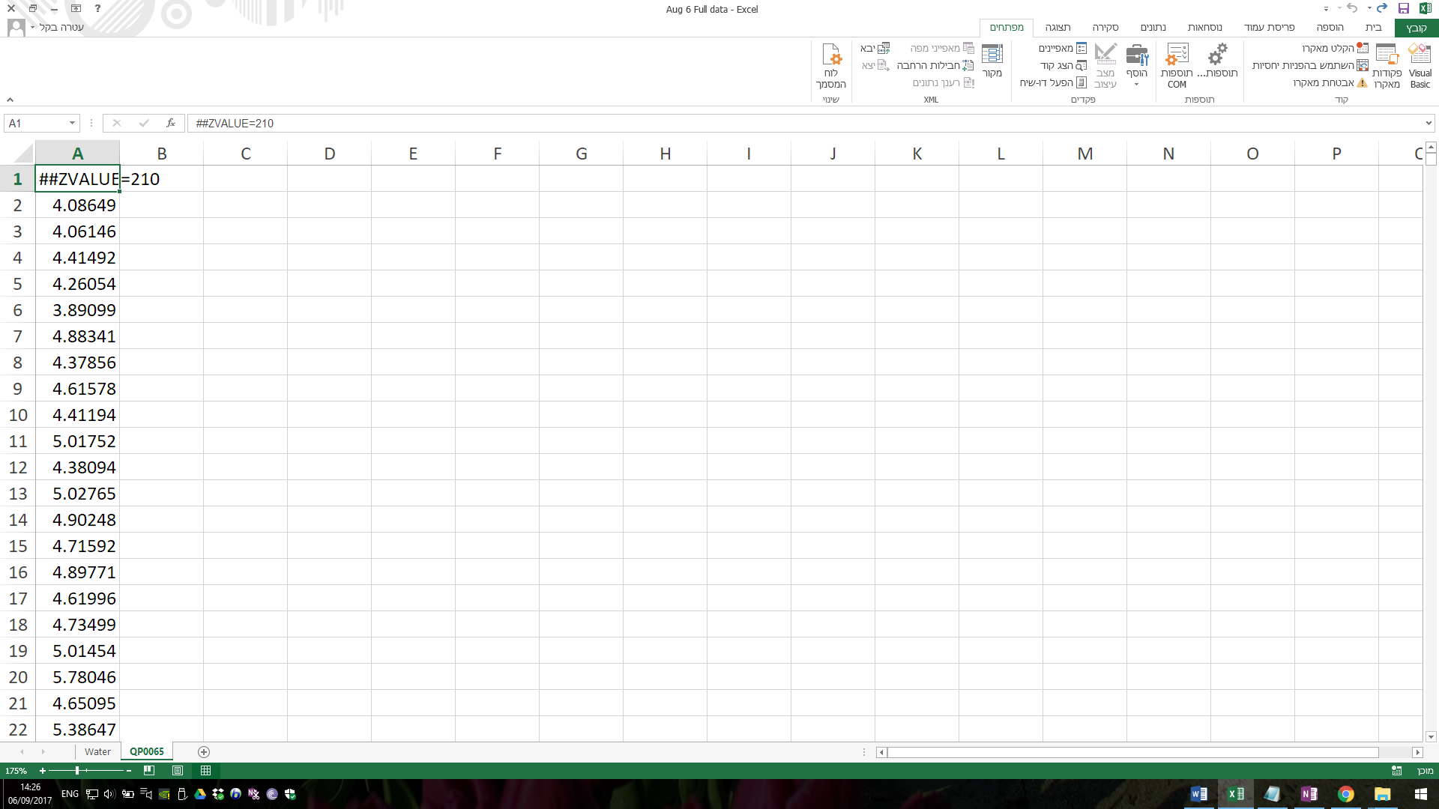Erase the top rows so that A1 = ##zvalue…
5. 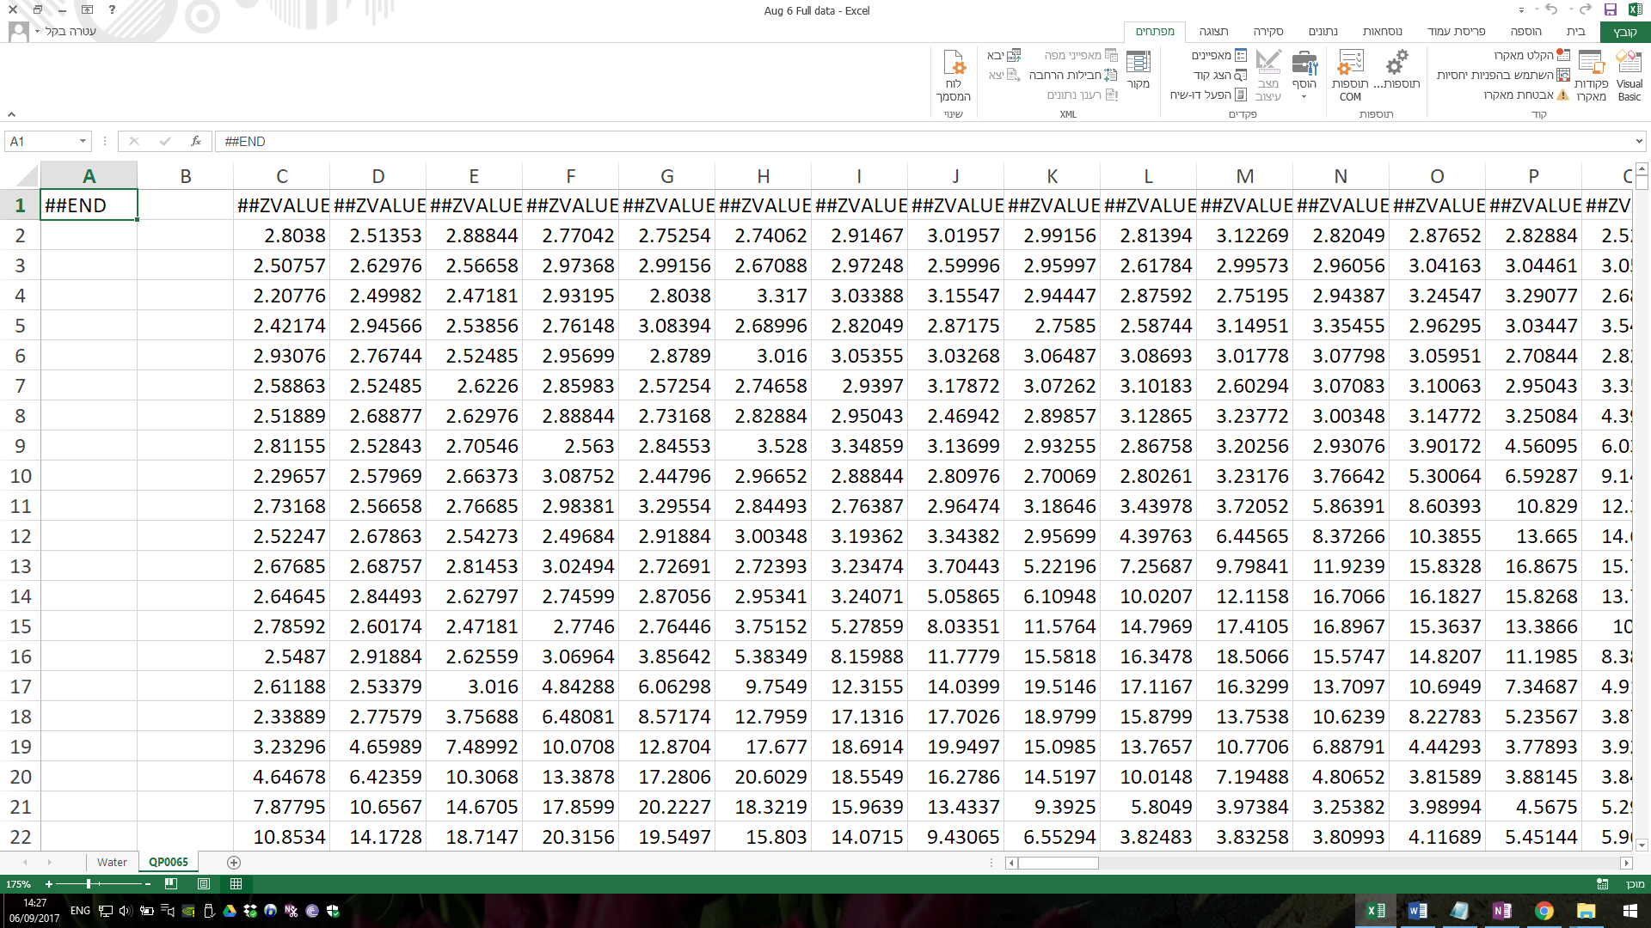Run macro loopM (cntrl+l) [Takes about 20 secs]
6. On the A column – insert the data id from the original file:

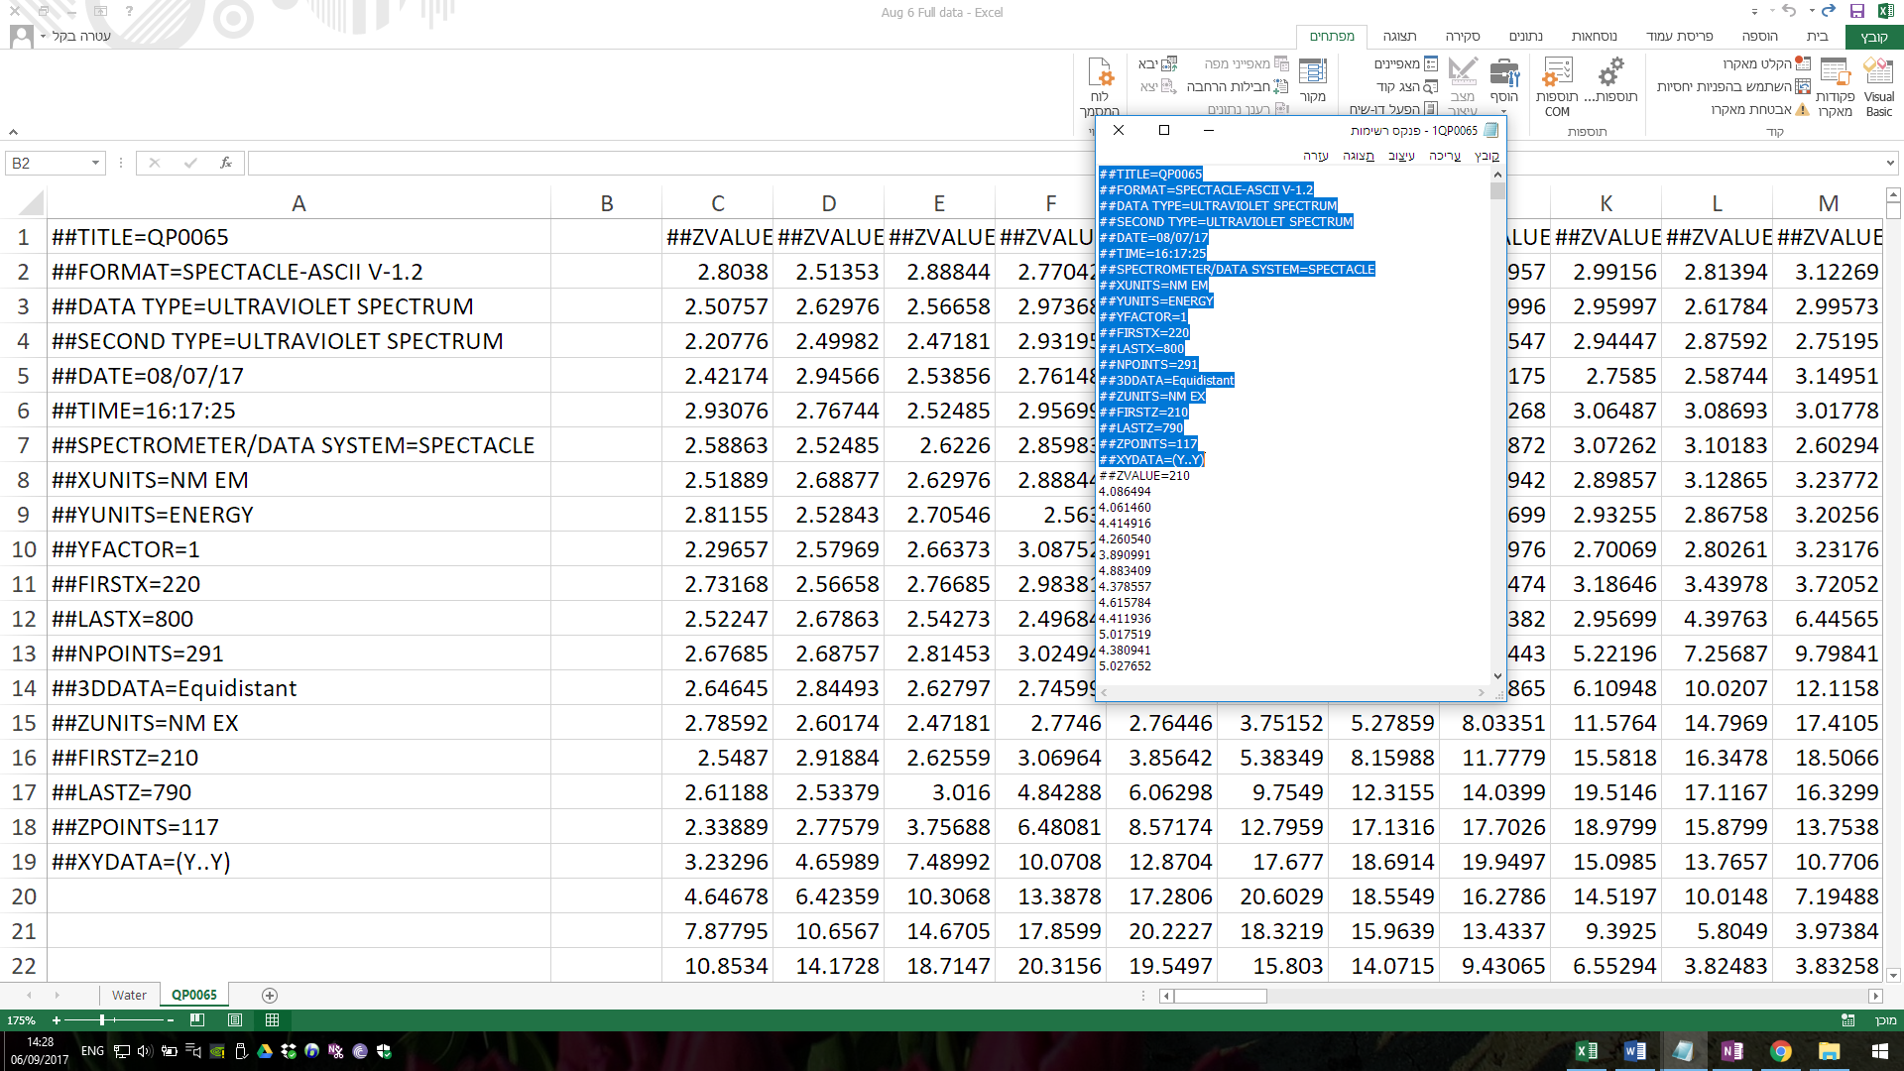

1. Add a 200-800 “emission wavelength” numbers (200 – 800, in 2 increments)

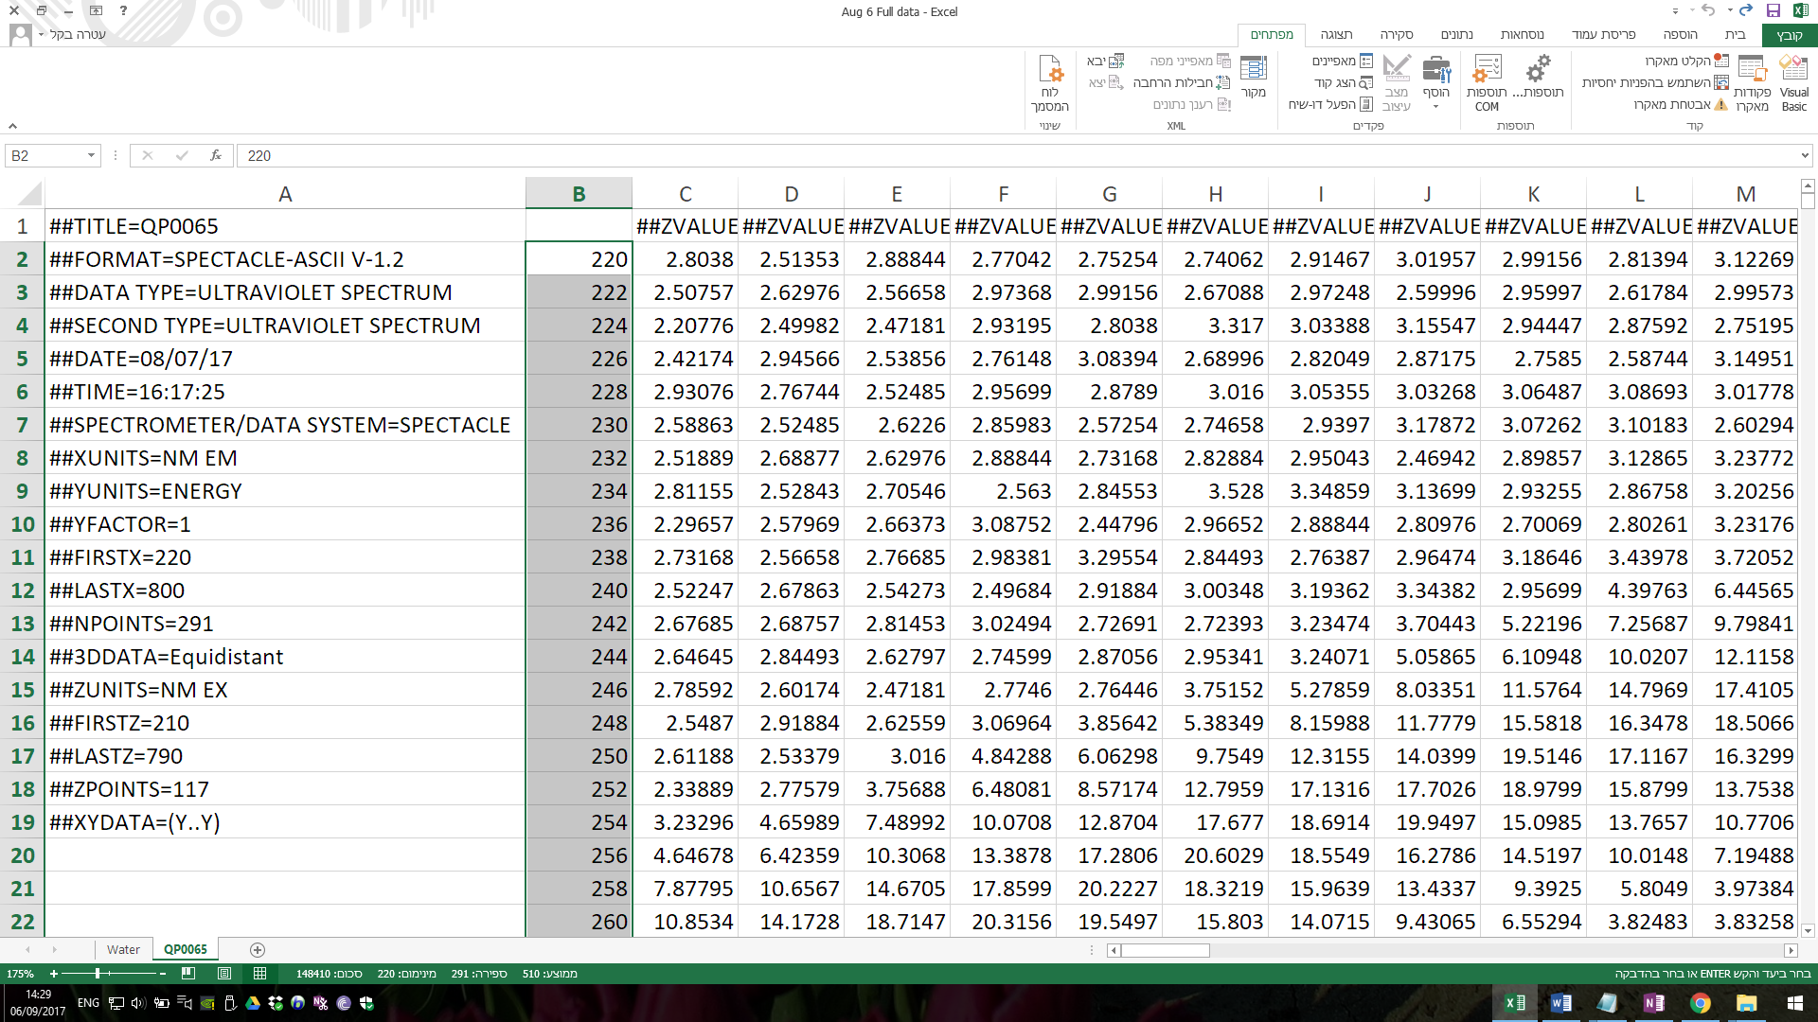

1. Find and replace “##ZVALUE=” to clean the excitation range.

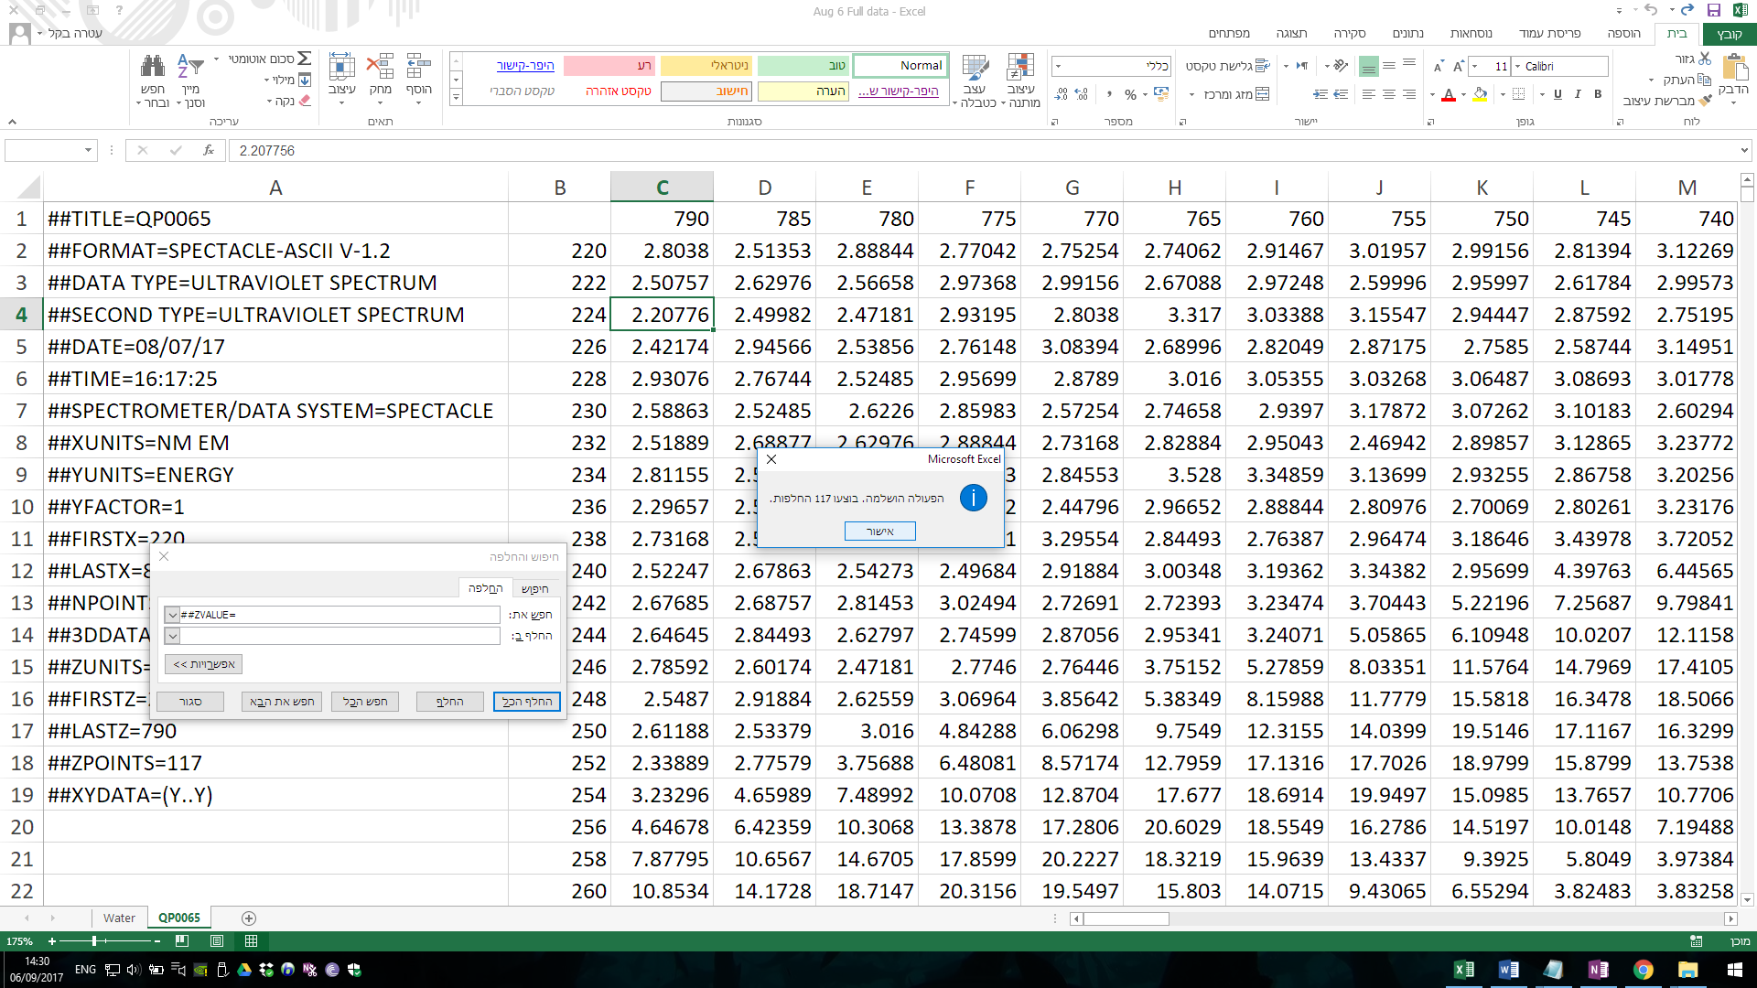

1. You can now add a countour graph this way:
2. Add a column to separate the “data ID” from the actual data.
3. Click Insert (הוסף) 🡪 Recommended charts (תרשימים מומלצים) 🡪 All charts (כל התרשימים) 🡪 Surface (פני שטח)

You should have this:

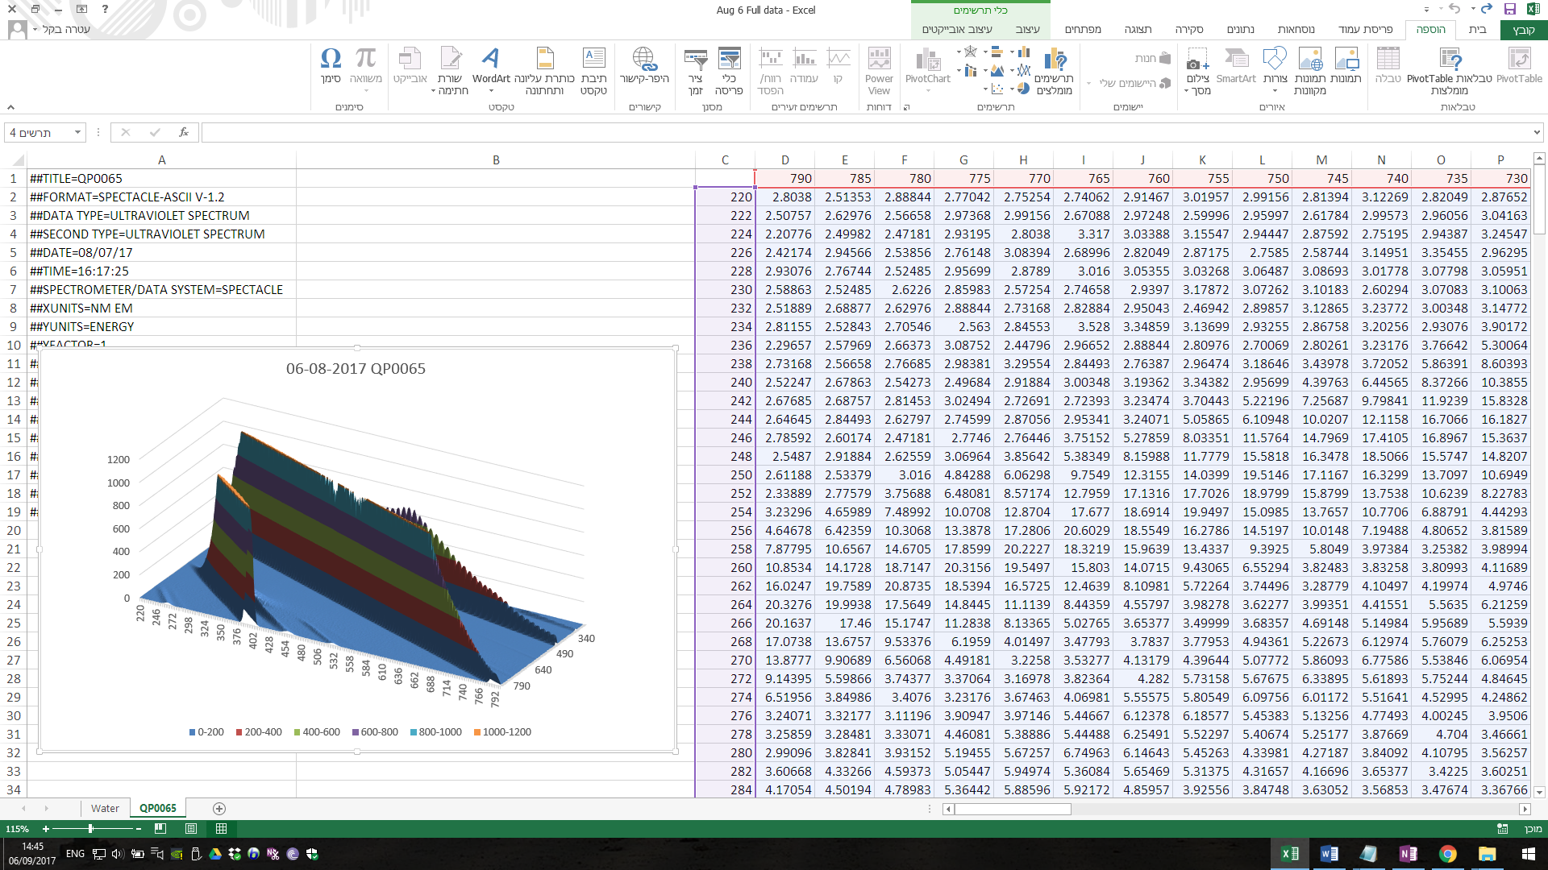

Macros:

Sub Sushi()

'

' Sushi ?????

' 1. select A1:A292 2. Cut 3. Paste in B1 4. Insert a column between B,A 5. select A1:A292 6. Delete and shift up

'

' ????? ?????: Ctrl+u

'

Application.Goto Reference:="R1C1:R292C1"

Selection.Cut

Range("B1").Select

ActiveSheet.Paste

Columns("B:B").Select

Selection.Insert Shift:=xlToRight, CopyOrigin:=xlFormatFromLeftOrAbove

Application.Goto Reference:="R1C1:R292C1"

Selection.Delete Shift:=xlUp

Range("A1").Select

End Sub

Sub LoopM()

Dim i As Integer

For i = 1 To 117

Call Sushi

Next i

End Sub